DESIGN PATTERN

* FACTORY METHOD

**Location in the code:** src/main/java/org/jabref/gui/desktop/ JabRefDesktop

The factory JabRefDesktop is on charge to create multiple types of desktops.

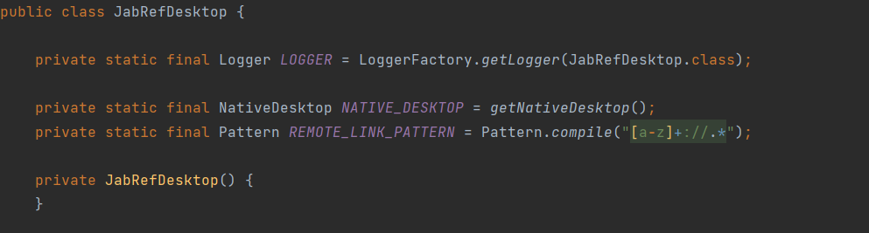

The static method getNativeDesktop() is the method that creates the desktops.

